Title: **Generator Effect** Worksheet: 22

Course: Electrical Applications Unit: Electrical Theory CLO: 3

Name ANSWER KEY Grade 18pts. Date ______________

**Objectives**

1. Student shall determine the current induced in a conductor when moved through a magnetic field.
2. Student shall apply Fleming’s Right Hand Rule also known as the generator effect.

**Assessment**

Students shall demonstrate a comprehension of the objectives listed above by scoring a minimum of 75% on this Worksheet. Grading shall be based on an answer key.

**Theory**

Fleming’s Right Hand Rule is used to determine the direction of *conventional current* that is induced in a conductor when brought in the presence of a magnetic field. If you place the thumb, first finger and second finger of your right hand in mutually perpendicular position, you may apply Fleming’s Right Hand Rule. The thumb shall point in the direction that the conductor will move. The first finger shall point in the direction of the magnetic *lines of force*. The second finger shall point in the direction that the induced *conventional current* will flow.

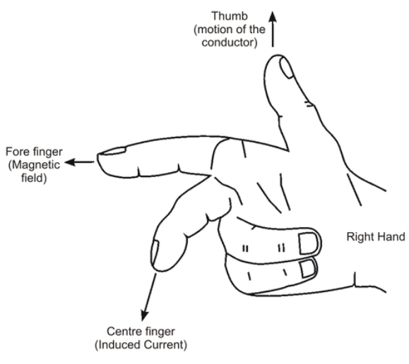

* Thu***m***b – the “m” in thumb stands for *movement* or *motion*.
* ***F***irst – the “F” in first stands for the *field* (magnetic field lines moving N to S).
* Se***c***ond – The “c” in second stands for the *conventional current* direction.

|  |  |
| --- | --- |
|  |  |

The cross-section of the conductor, the circle shown above, has either a plus “+” or a minus “-” sign. This indicates the direction of *conventional current* flow. A plus sign will indicate that current is coming out of the conductor. A minus sign indicates that current is going into the conductor.

**Instructions**

Given the graphics below, label the poles of each electromagnet and the direction of the *conventional current* induced in the conductor.



S

N

N

S



S

S

N

N



S

N

S

N

**Evaluations**

1. Flux lines are lines of force that flow from the south pole to the north pole outside of the magnet.
   1. True
   2. False
2. Magnetic lines of force have tension, which keeps them as short as possible.
   1. True
   2. False
3. Opposite poles ________, and like poles ________.
   1. Attract, Repeal
   2. Repeal, Attract